**AWS PROJECT SUBMISSION**

Name: Sagala Naga Tanvi

Email ID: [tanvisagala1007@gmail.com](mailto:tanvisagala1007@gmail.com)

University: Vellore Institute of Technology, Vellore

Phone no: 8340904020

**SCREENSHOTS NEEDED FOR DASHBOARDS**

**1.AWS login screen with username**

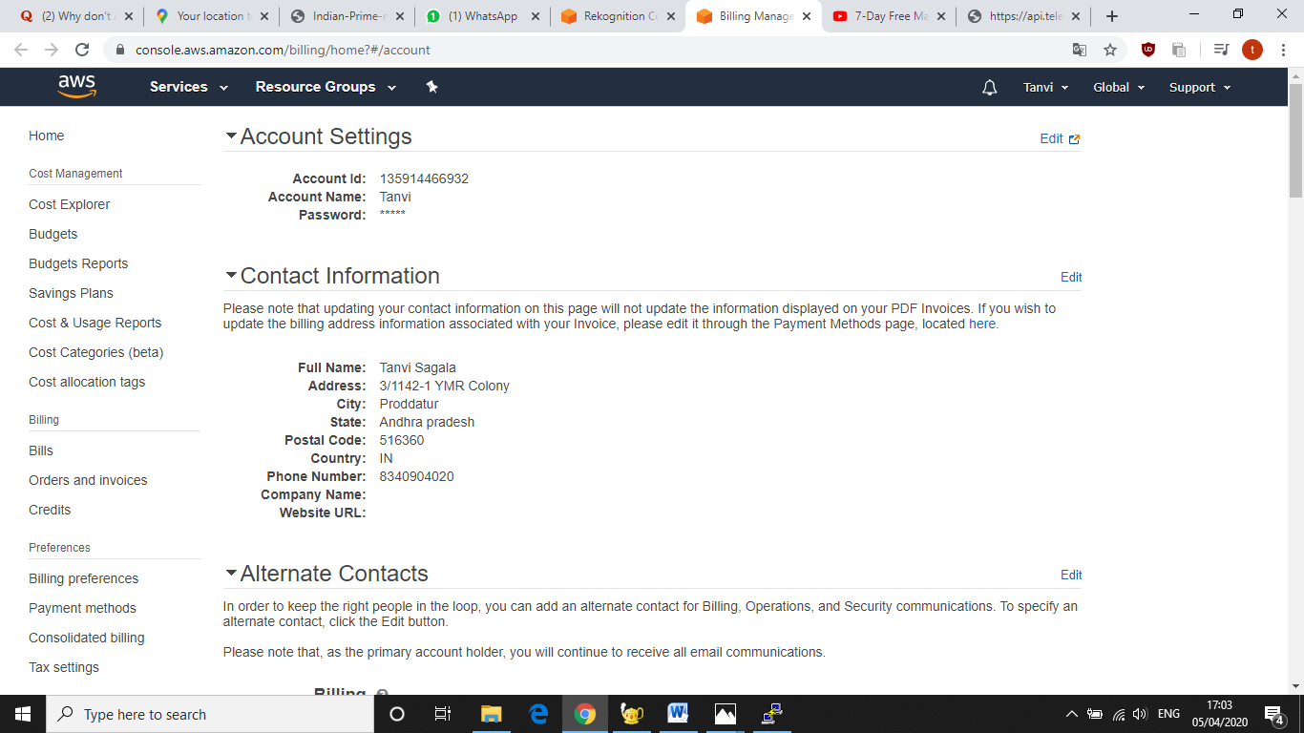

**2.EC2 Dashboard**

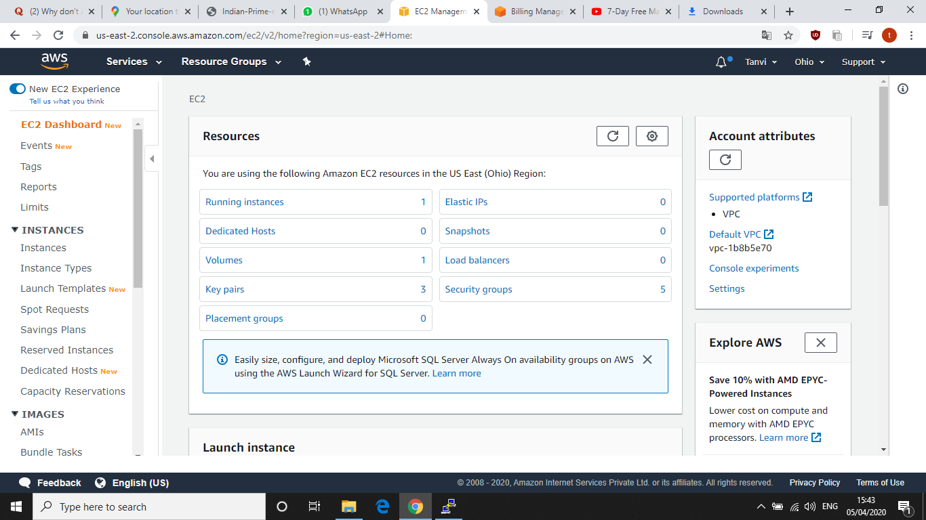

**3.S3 Dashboard**

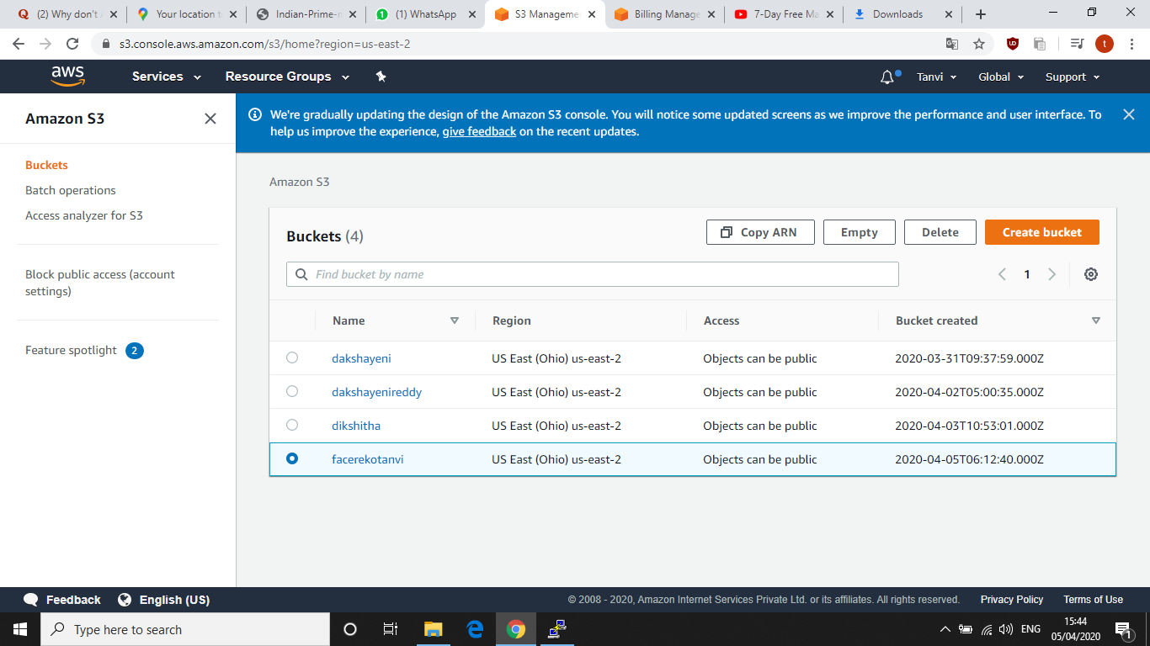

**4.Rekognition Dashboard**

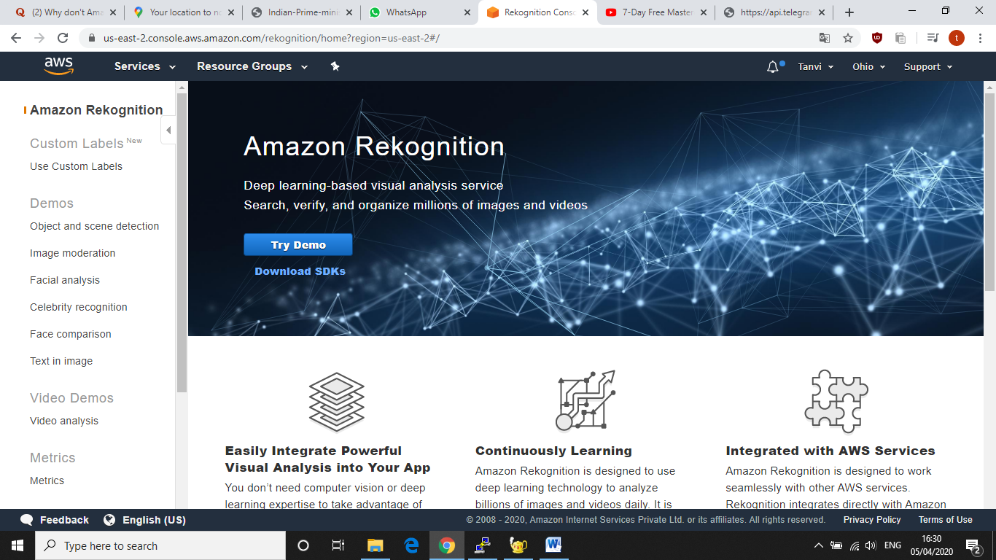

**SCREENSHOTS FOR EC2**

**1.Choosing and AMI**

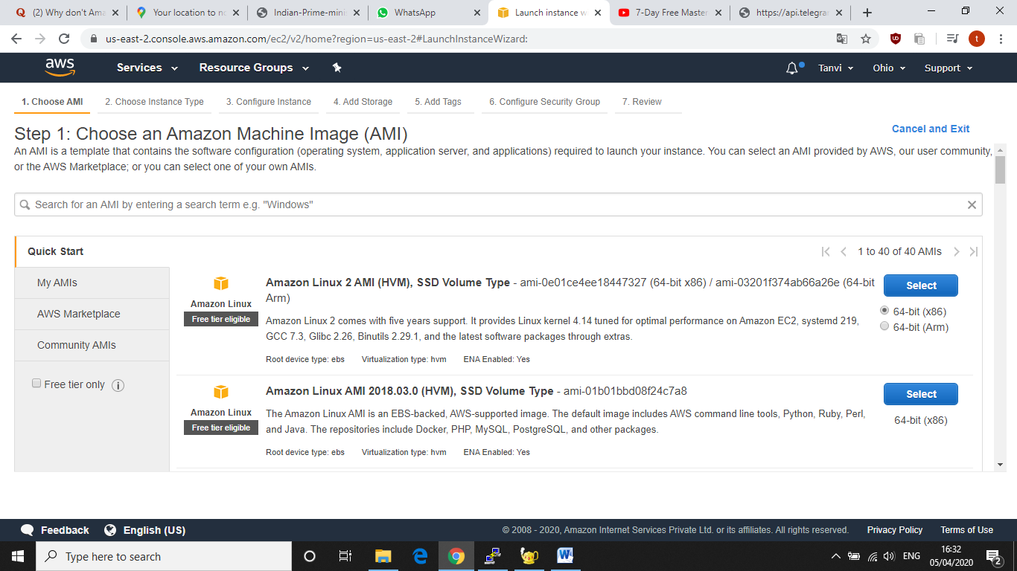

**2.Choosing an instance type**

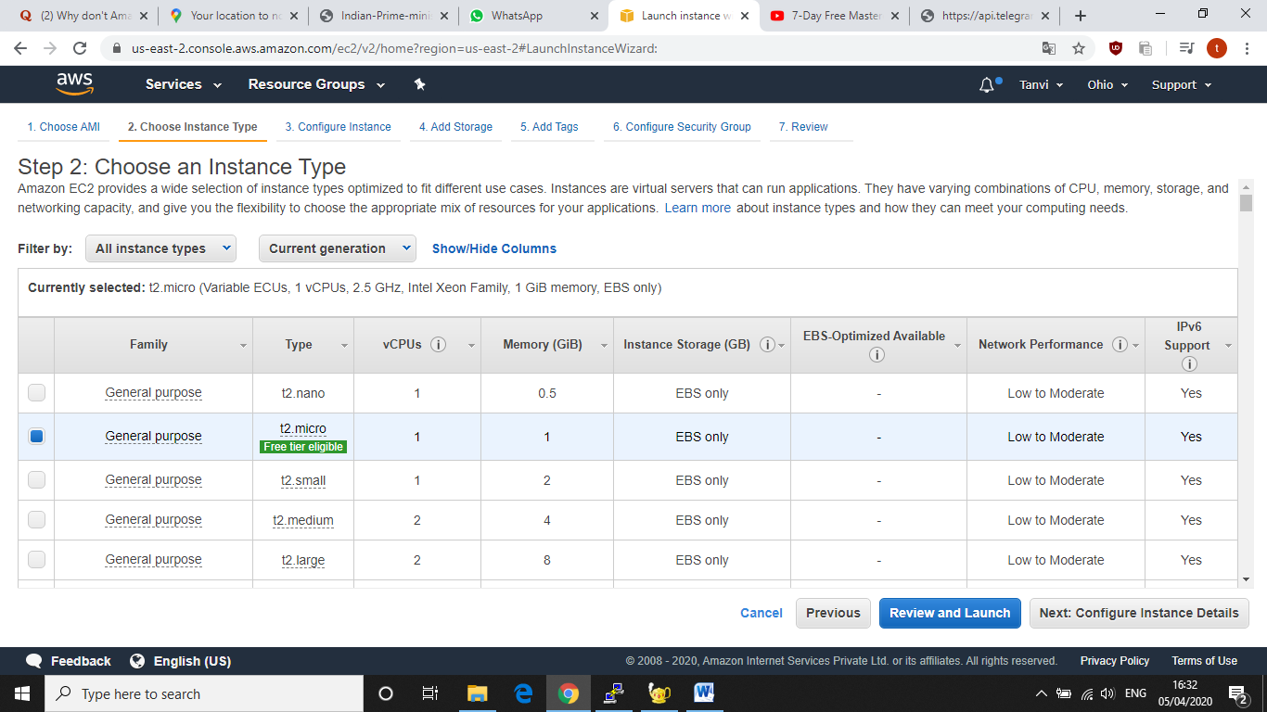

**3.Adding Storage**

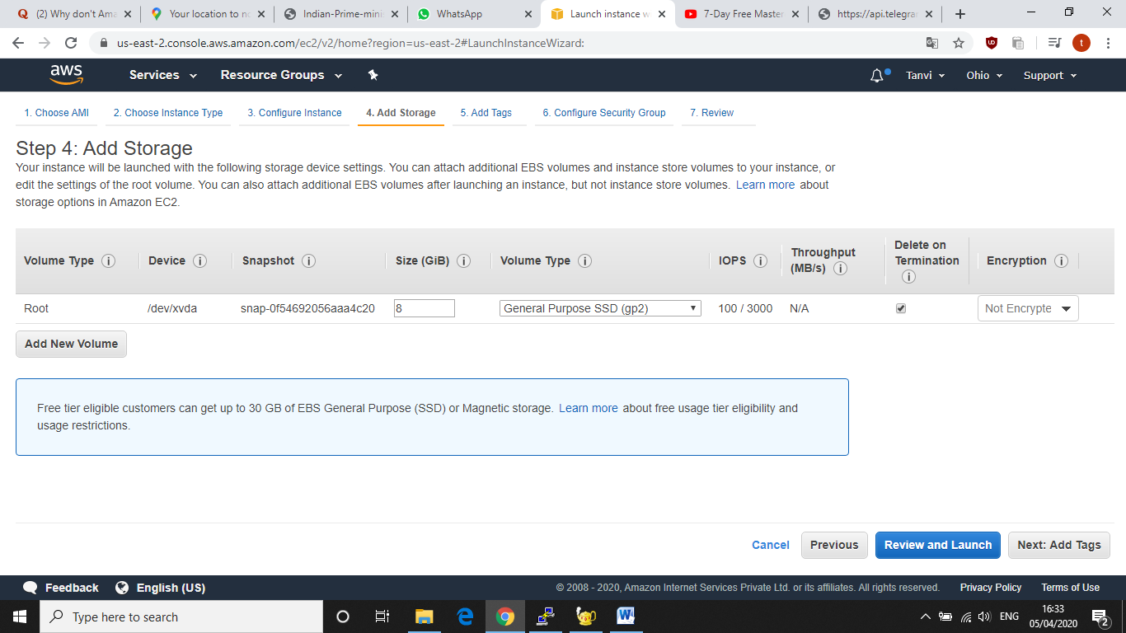

**4.Configure Security Group**

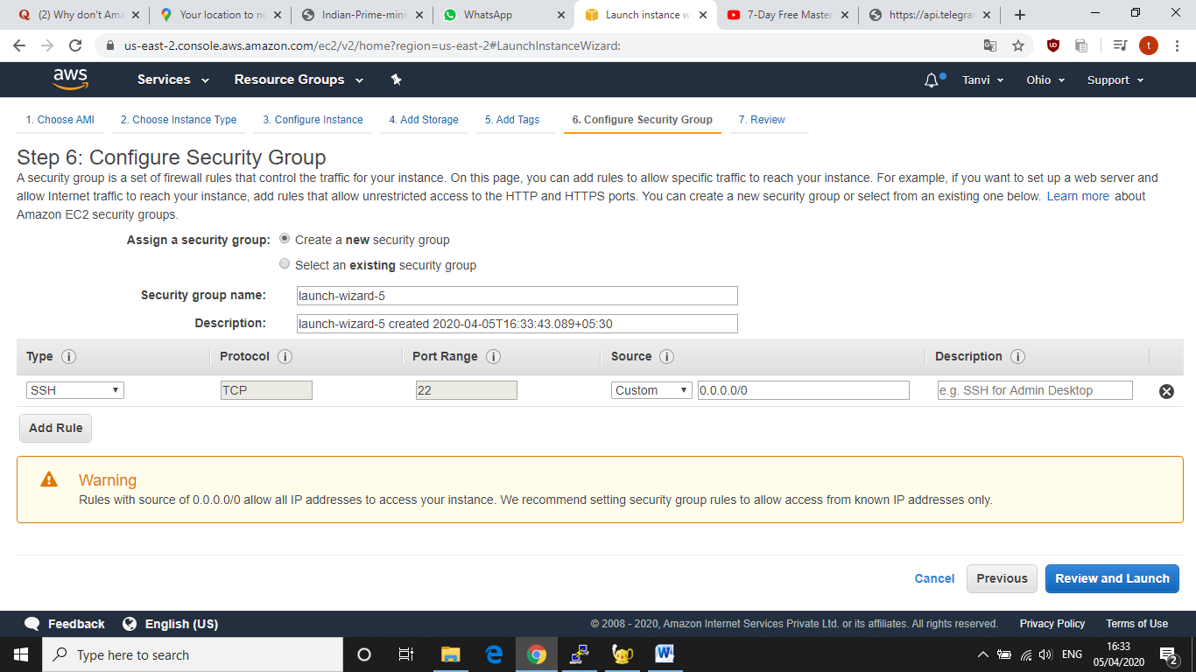

**5.Key Pair Download**

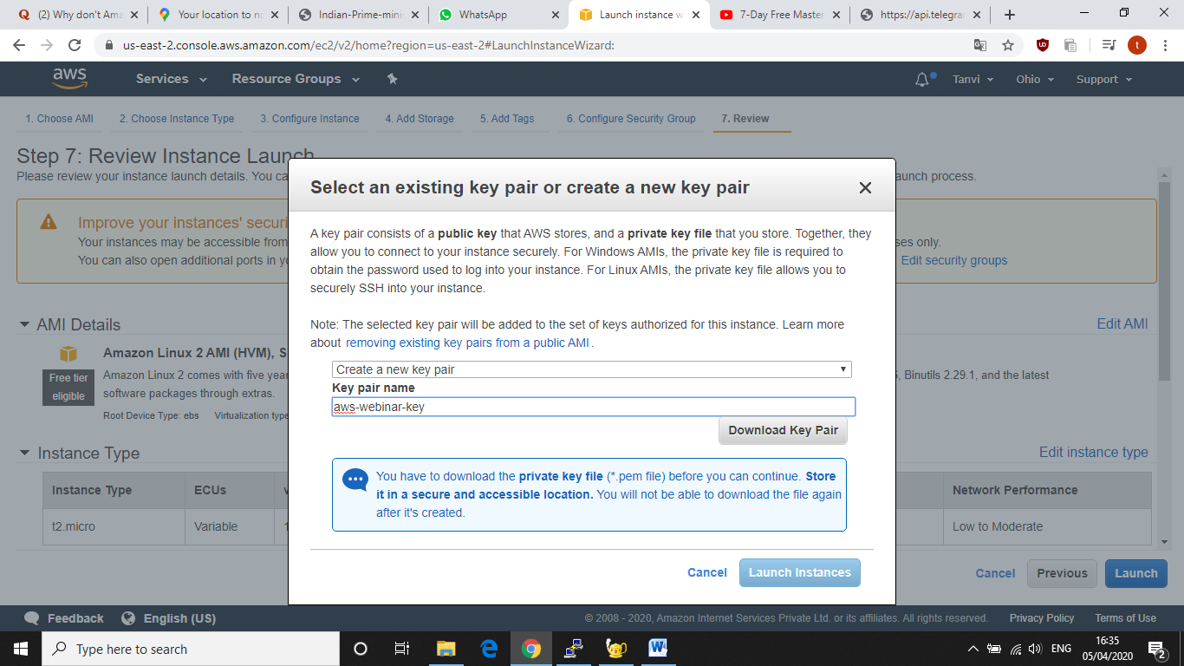

**6.Puttygen convertsion from pem to ppk**

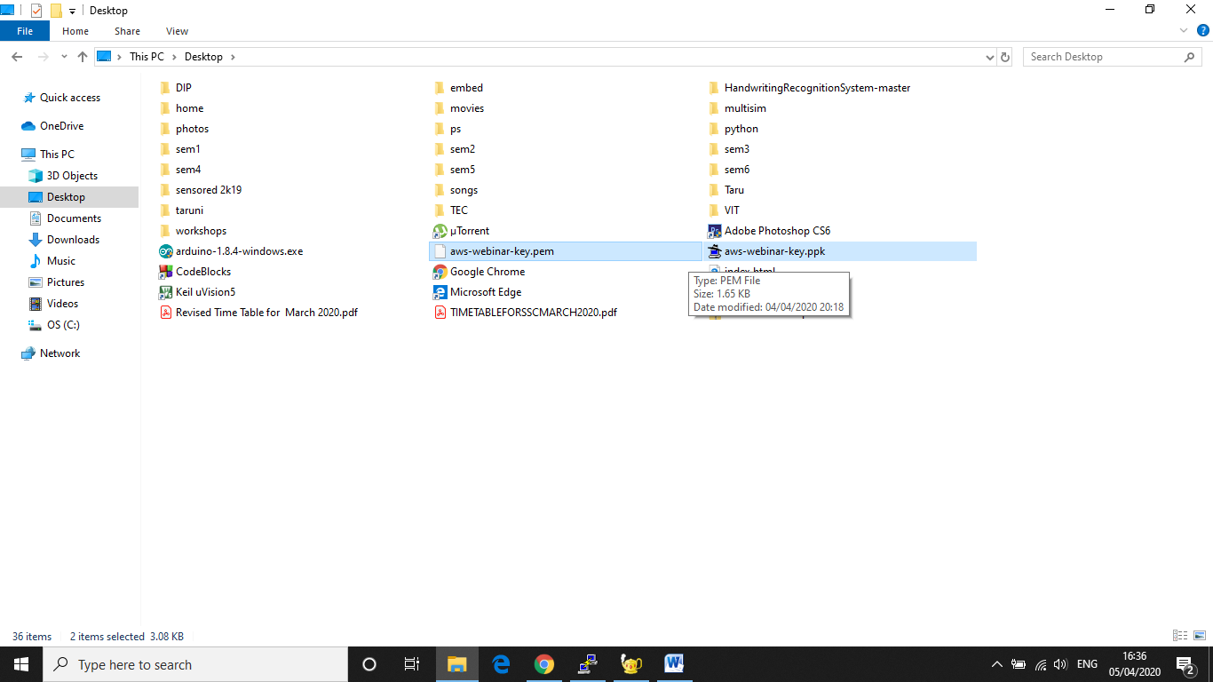

**7.Logged in EC2 back screen**

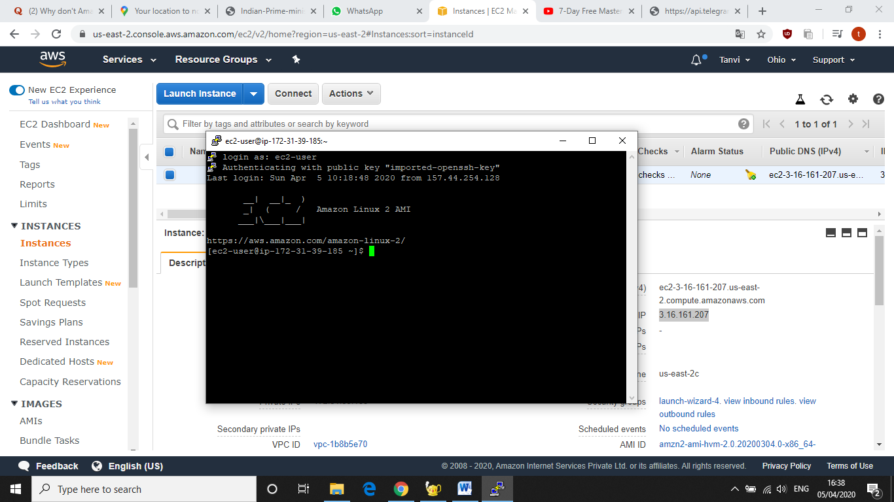

**8.IP address hosting**

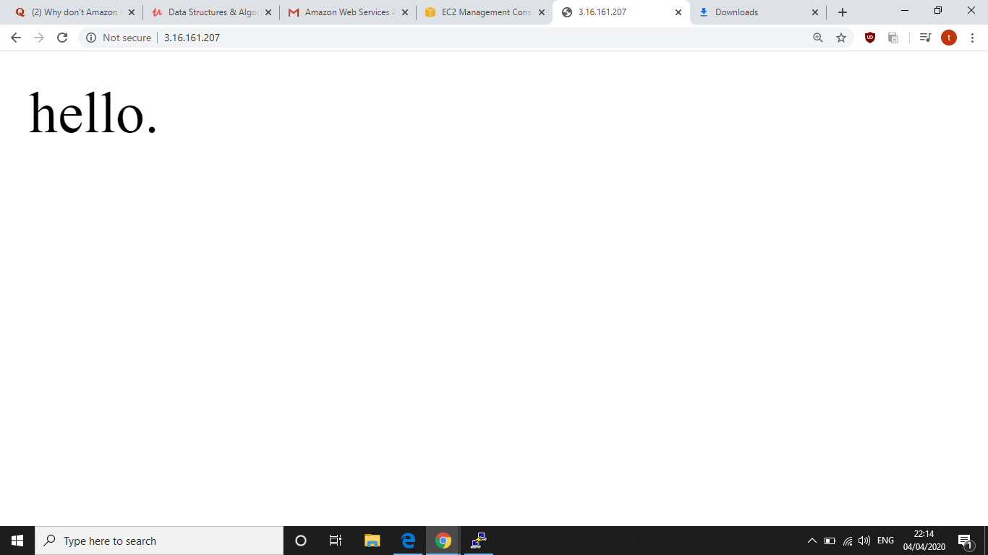

**SCREENSHOTS FOR S3**

**1.Creating a Bucket**

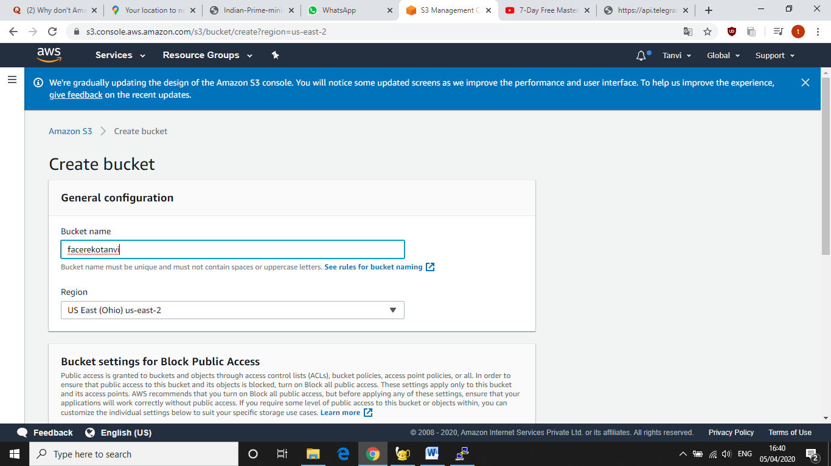

**2.Uploading an Object**

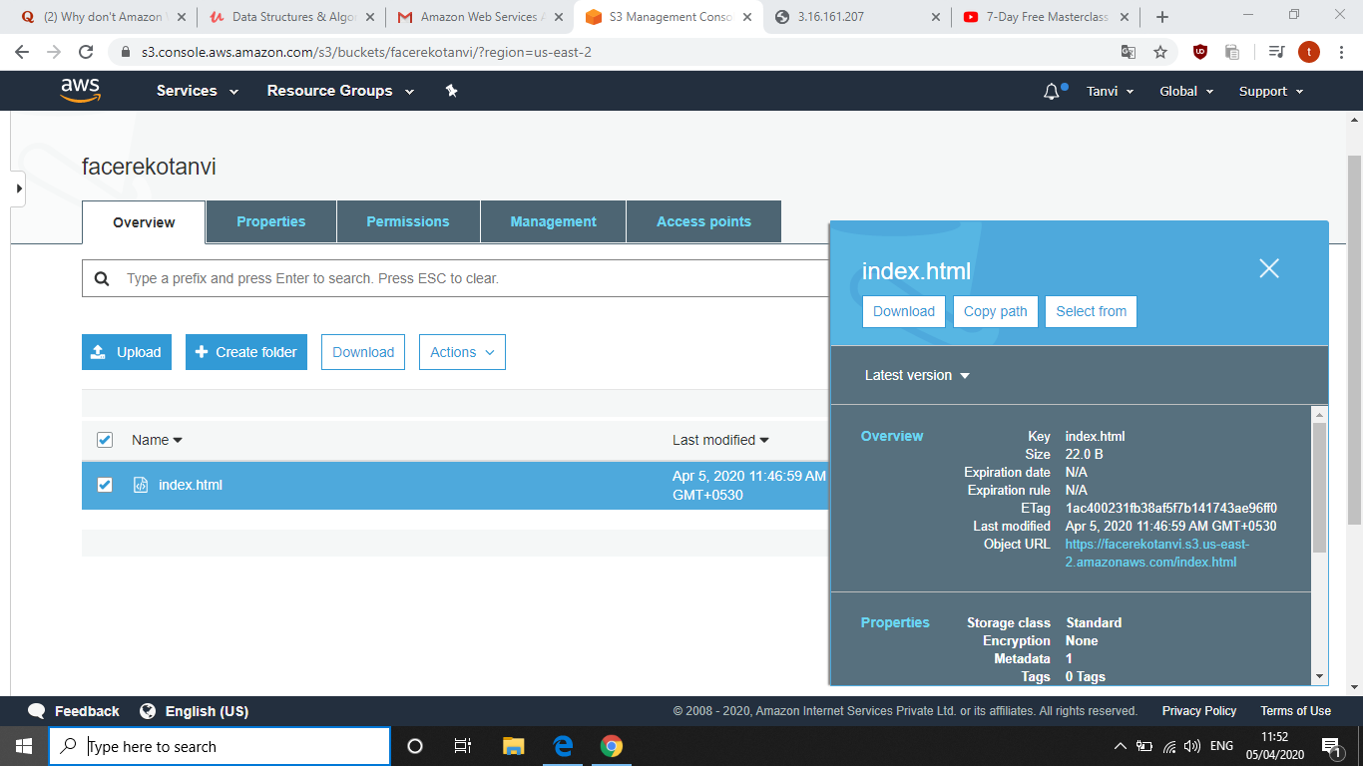

**3.Enabling static website**

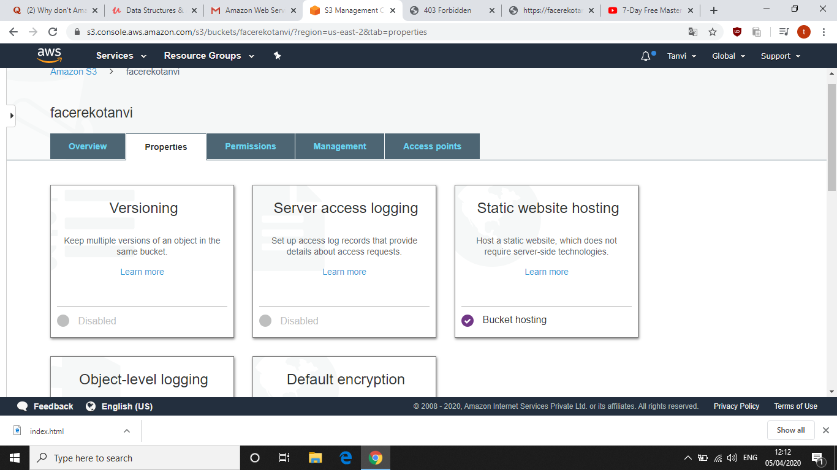

**4.Making the object public**

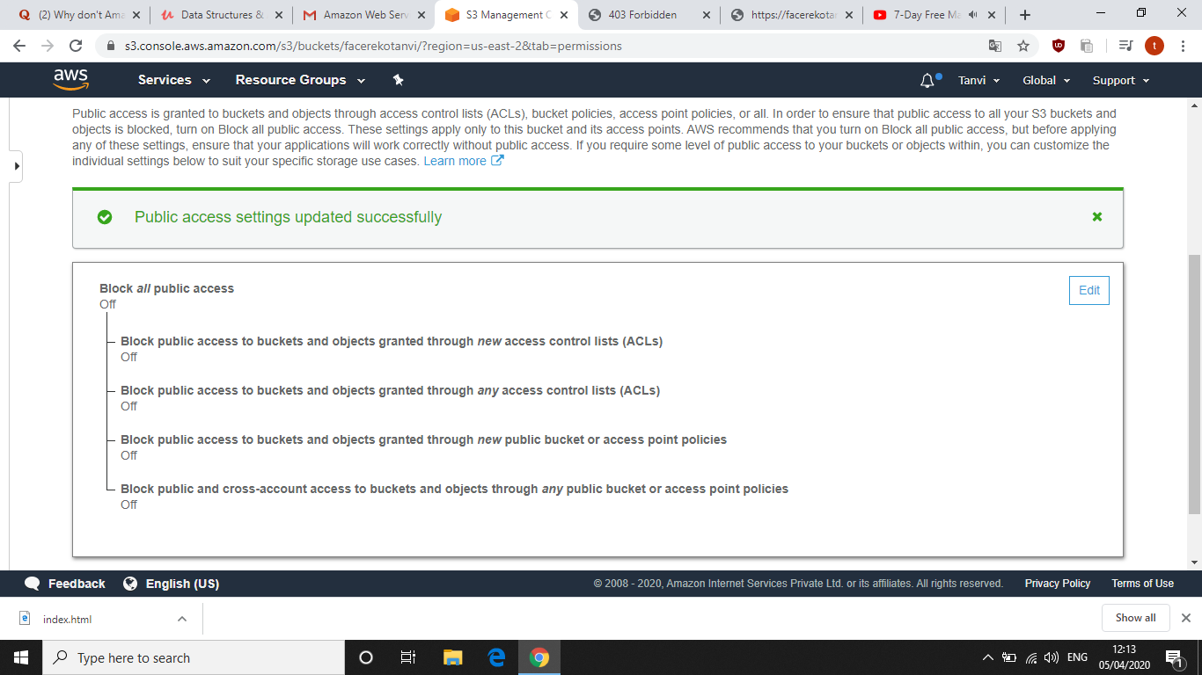

**5.Checking the S3 link on browser**

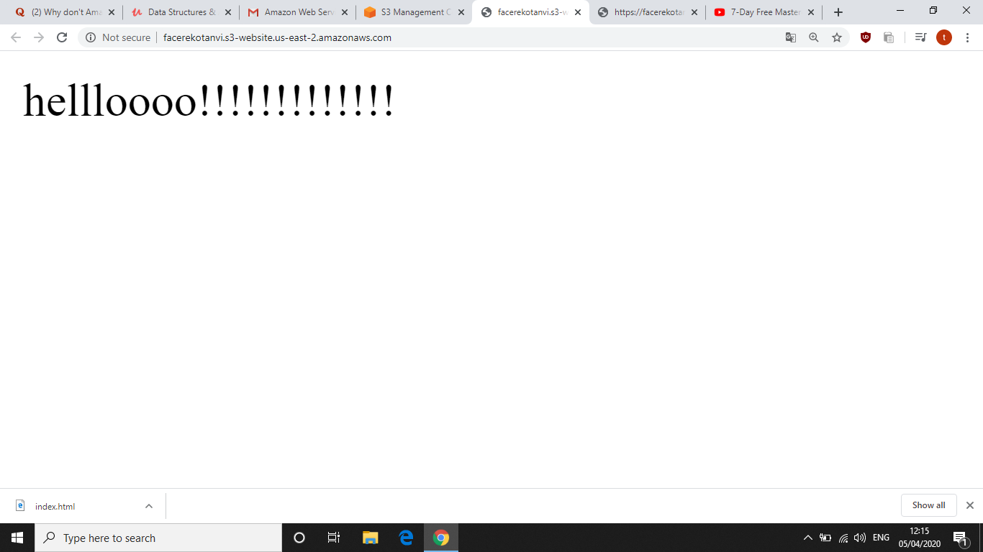

**SCREENSHOTS NEEDED FOR REKOGNITION**

**1.Face Detect**

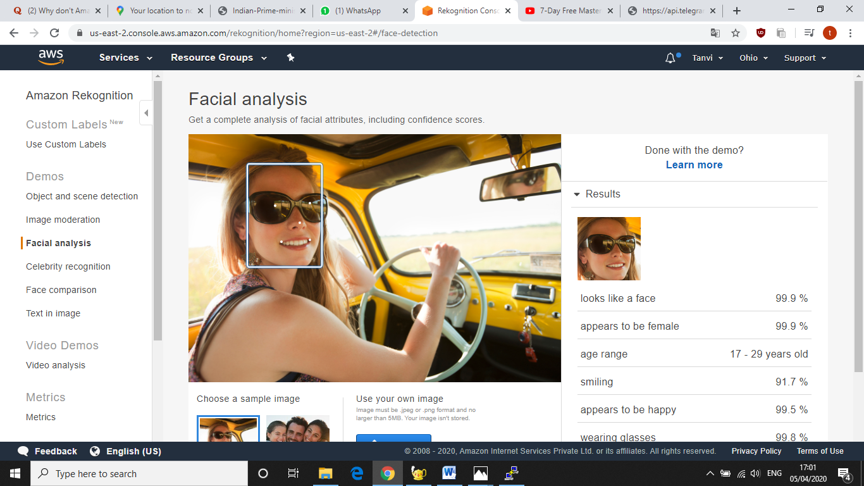

**2.Face Comparision**

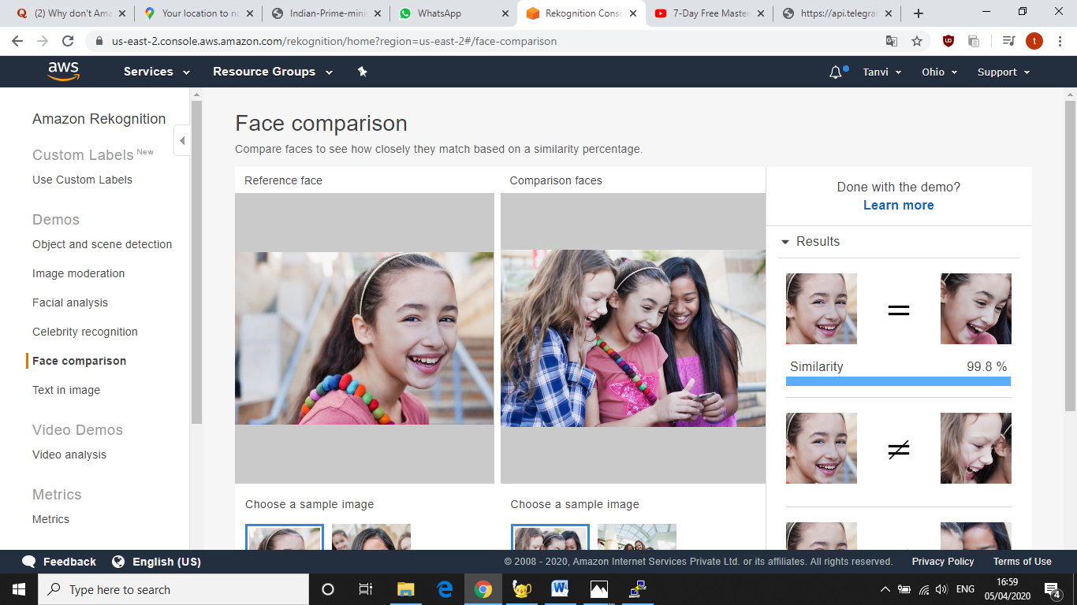

**3.Celebrity Rekognition**

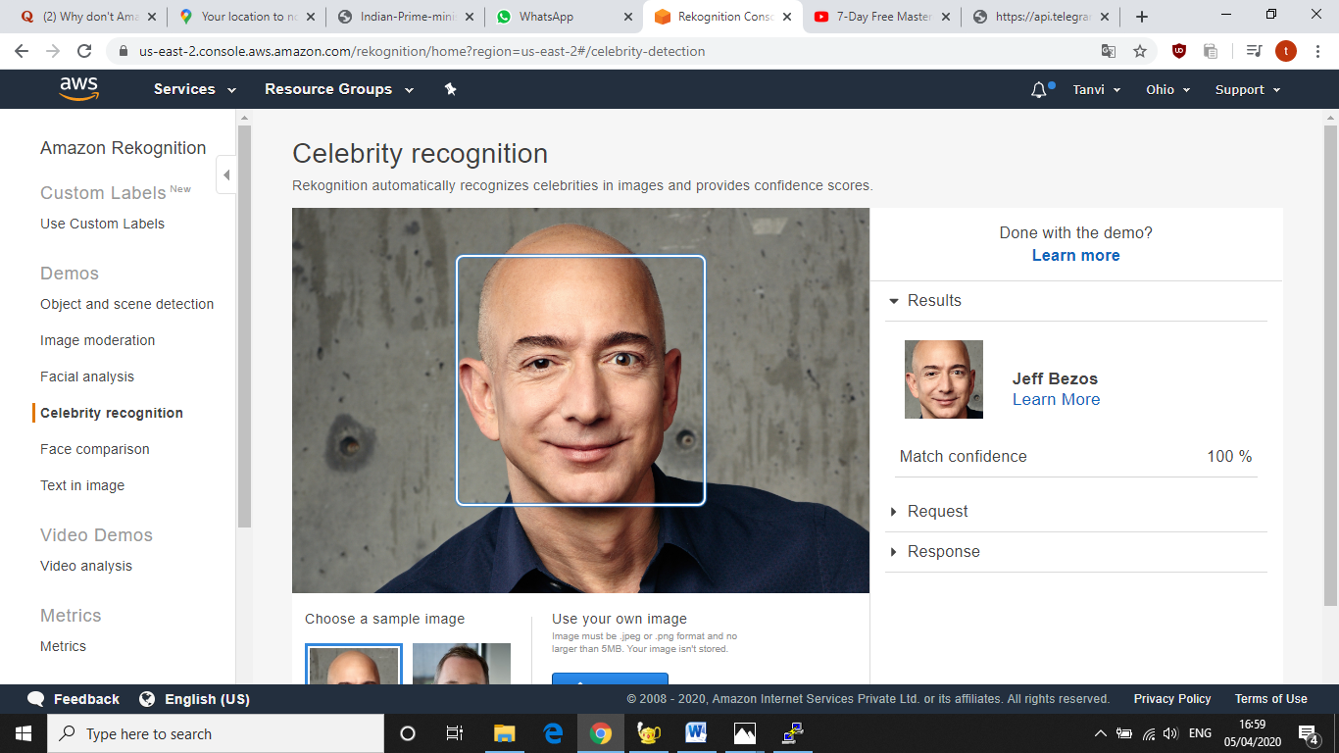

**4.Text in image**

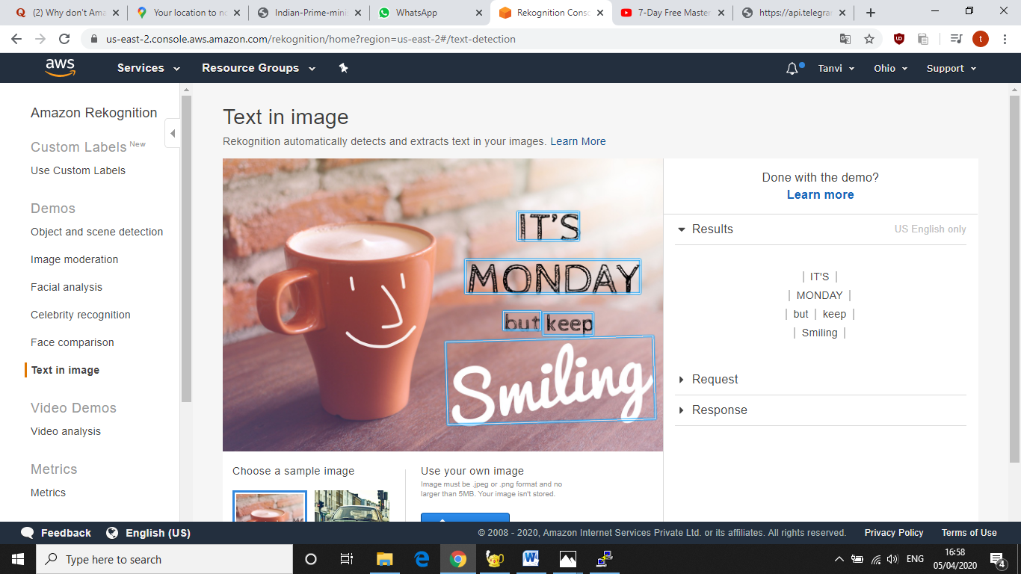

**SCREENSHOTS NEEDED FOR EC2 AND S3**

**1.Installing aws-sdk**

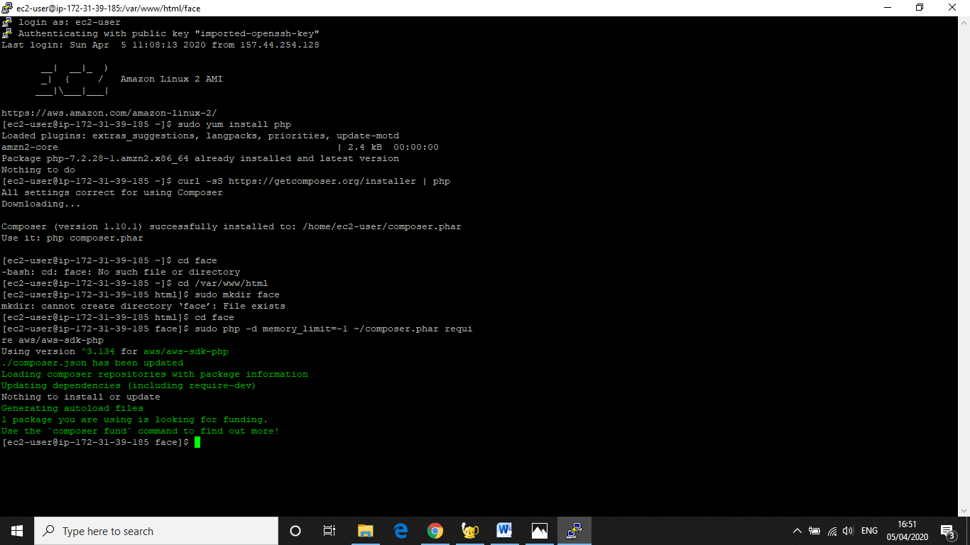

**2.Installing PHP**

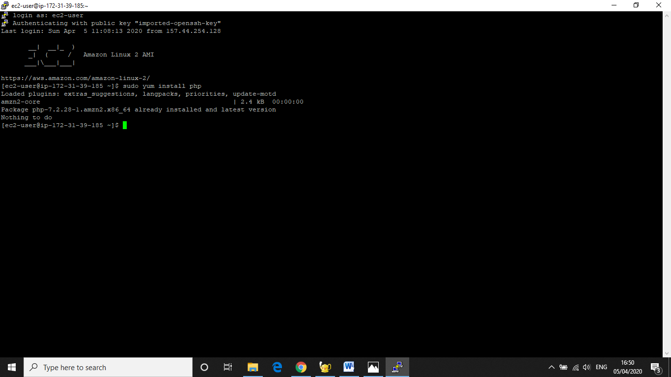

**3.index3.php file code**

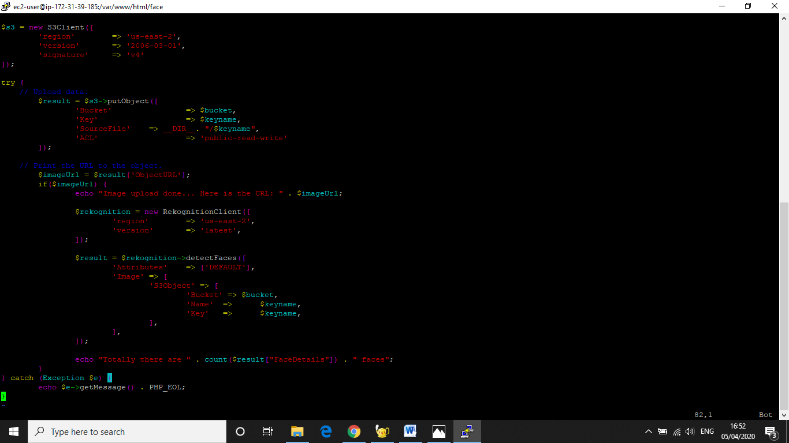

**4.Upload Success Screenshot**

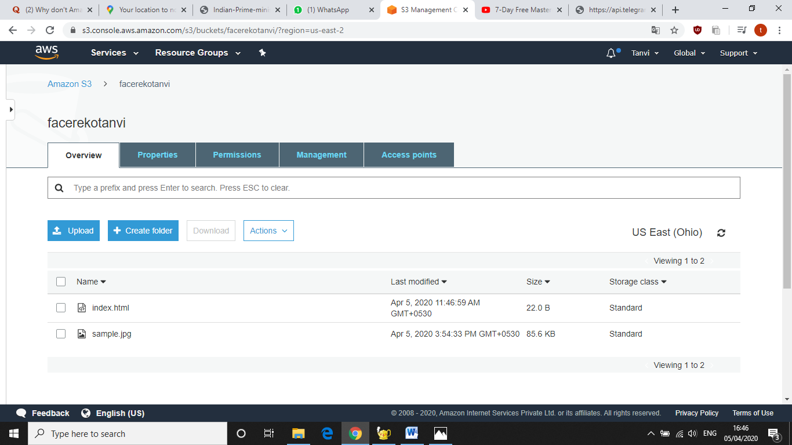

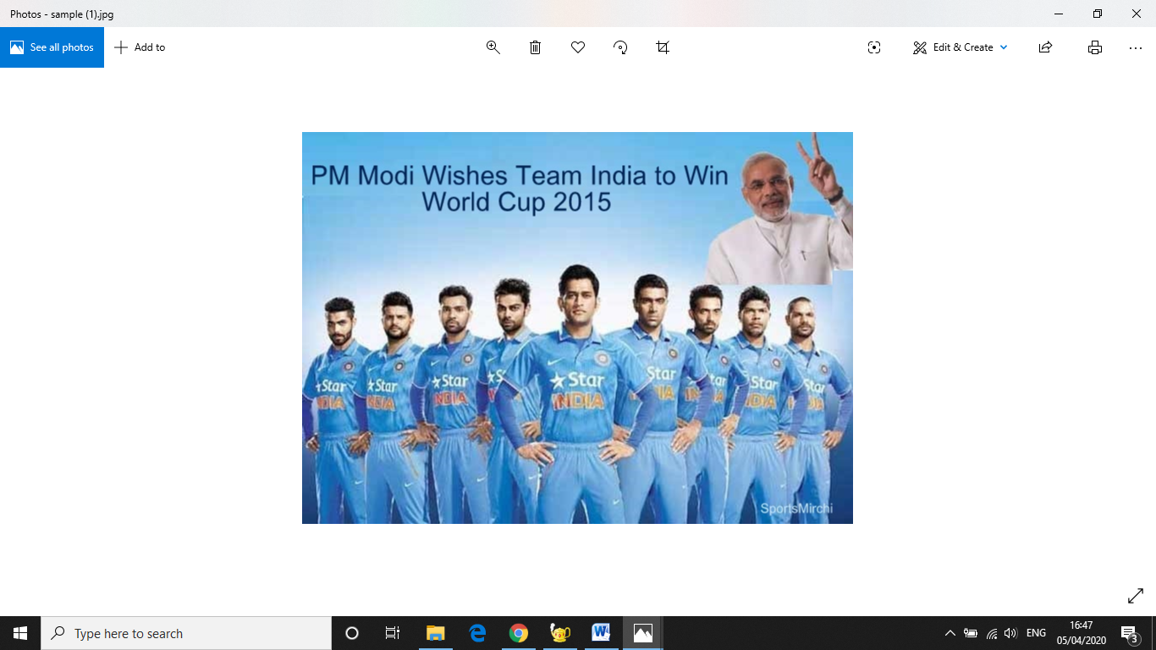

**SCREENSHOTS FOR EC2 & REKOGNITION**

**1.Face Detect Success Screenshot**

